Mr. Sabado, Algebra 2 Friday, October 25, 2013

Homework

Due Today:
Chapter 4 Test Review #1
Homework Calendars

Due 10/29:
Chapter 4 Test Review #2


Presentations will be held next Thursday and Friday.

Agenda

- Warm-Up
- HW Check
- Turn in HW Calendars

- Review: Write Quadratic in Standard Form

- Chapter 4 Review Stations

- Homework

Warm-Up
Solve
- 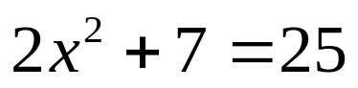

2) Use the quadratic formula to solve.
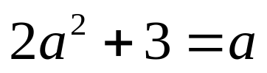`
whs.saba.do



“It is never too late to be what you might have been.”
- G. Eliot

